**Title:**

Performance analysis of a common source (CS) E-MOSFET amplifier circuit by varying the loads and justification of the analysis with respect to simulated and experimental data (followed by the given constraints).

**Objective**:

Design a common source E-MOSFET amplifier circuit and analyze the gain with varying the loads. Finally, a complete analysis will be expected with respect to experimental and simulated data.

**Literature review:**

MOSFET devices belong to the group of Insulated Gate Field Effect Transistor (IGFETs). MOSETs like all other IGFETs has three terminals, which are called Gate (G), Source (S), and Drain (D). In PMOS, the body terminal is held at the most positive voltage in the circuit and in NMOS, it is held at the most negative voltage in the circuit.

There are four types of MOSFETs: enhancement n-type MOSFET, enhancement p-type MOSFET, depletion n-type MOSFET, and depletion p-type MOSFET. If the channel between the drain and the source is an induced channel, the transistor is called enhancement transistor. Throughout the handout, we will concentrate on analyzing the enhancement type MOSFET. If we put the drain and source on ground potential and apply a positive voltage to the gate, the free holes (positive charges) are repelled from the region of the substrate under the gate (channel region) due to the positive voltage applied to the gate. The holes are pushed away downwards into the substrate leaving behind a depletion region. At the same time, the positive gate voltage attracts electrons into the channel region. When the concentration of electrons near the surface of the substrate under the gate is higher than the concentration of holes, an n region is created, connecting the source and the drain regions. In the case of an enhancement type NMOS transistor the threshold voltage is positive, whereas an enhancement type PMOS transistor has a negative threshold voltage. So, in order for the current to flow from drain to source, the condition that should be satisfied is VG > Vth, where VG is the gate voltage and Vth is the minimum voltage required to form a channel between drain and source so that carriers can ow through the channel. By changing the applied gate voltage, we can modulate the conductance of the channel.

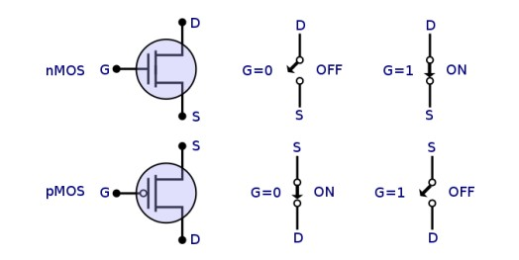

**Figure: Symbols for enhancement NMOS and PMOS transistors**

**Apparatus:**

|  |  |  |  |
| --- | --- | --- | --- |
| **Apparatus** |  |  | **Quantity** |
| MOSFET | 1 |  |  |
| Trainer board | 1 |  |  |
| Resistors | 8 |  |  |
| Oscilloscope | 1 |  |  |
| Multimeter | 1 |  |  |
| Signal Generator | 1 |  |  |
| Capacitors | 1 |  |  |
| DC Power Supply | 1 |  |  |

**Experimental data table**:

Table 1

|  |  |  |  |  |
| --- | --- | --- | --- | --- |
| **VDD** | **VD** | **VDD-VD** | **ID = (VDD-VD) / RD** | **VDS** |
| 10 V | 95.7 mV | 9.91 V | 6.67 mA | 9.98 V |

Table 2

|  |  |  |  |
| --- | --- | --- | --- |
| **Load resistor** | **Input voltage** | **Output voltage** | **Gain** |
| 1k | 400 mV | 3.9 mV | 00.00975 |
| 4.7k | 420 mV | 10.1 mV | 0.024 |
| 10k | 420 mV | 9.4 mV | 0.022 |
| 100k | 420 mV | 13.1 mV | 0.031 |

**Simulated data table:**

Table 3

|  |  |  |  |  |
| --- | --- | --- | --- | --- |
| **VDD** | **VD** | **VDD-VD** | **ID = (VDD-VD) / RD** | **VDS** |
| 10V | 7.966 V | 2.004 | 5.311 mA | 10 V |

Table 4

|  |  |  |  |
| --- | --- | --- | --- |
| **Load resistor** | **Input voltage** | **Output voltage** | **Gain** |
| 1k | 16.6V | 9.91mV | 0.597 |
| 4.7k | 16.7V | 43.7mV | 2.62 |
| 10k | 16.03V | 95.2mV | 5.94 |
| 100k | 16.2V | 258.9mV | 15.98 |

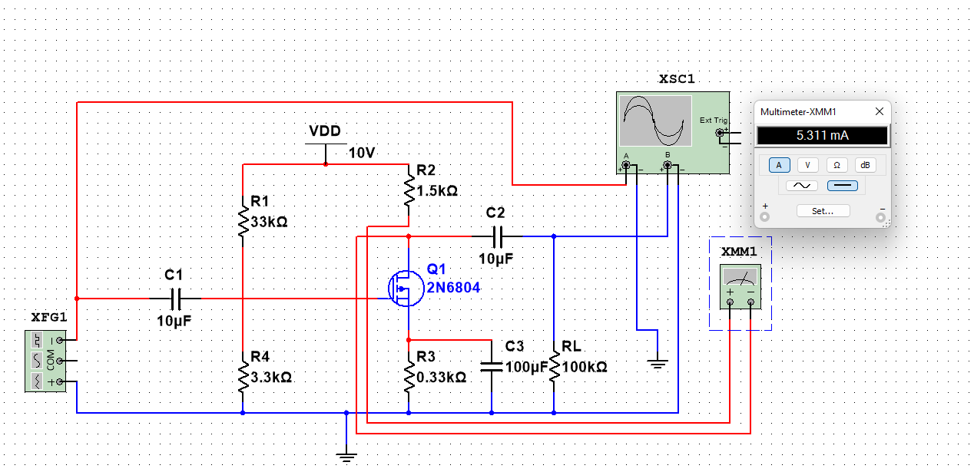

For load resistance 1 kilo ohm:

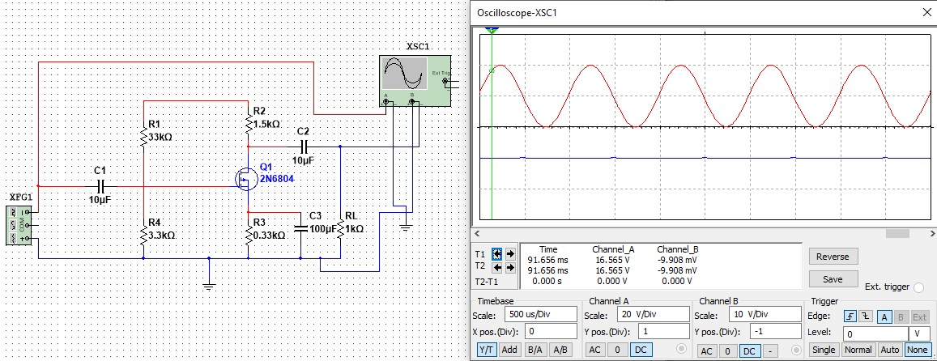

For load resistance 4.7 kilo ohm:

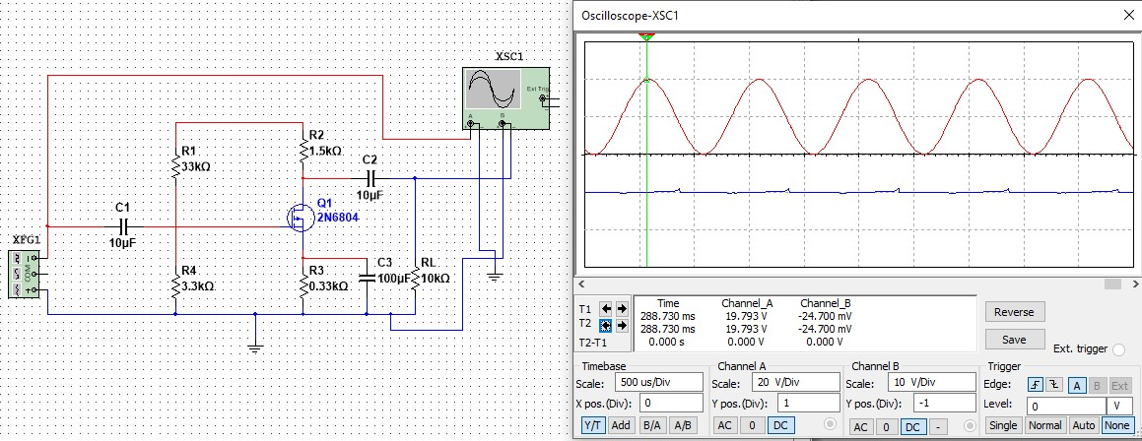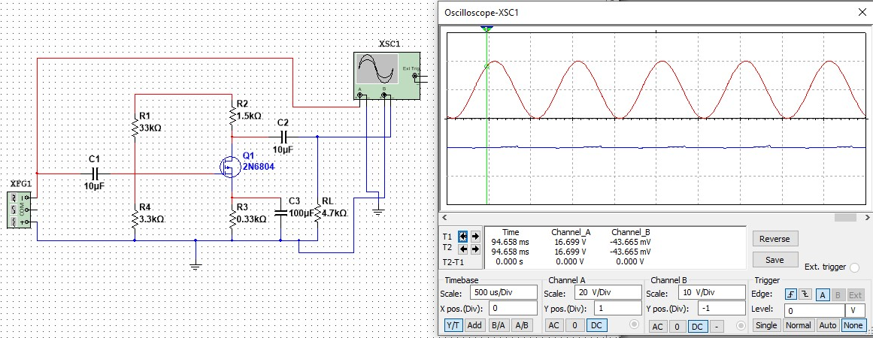

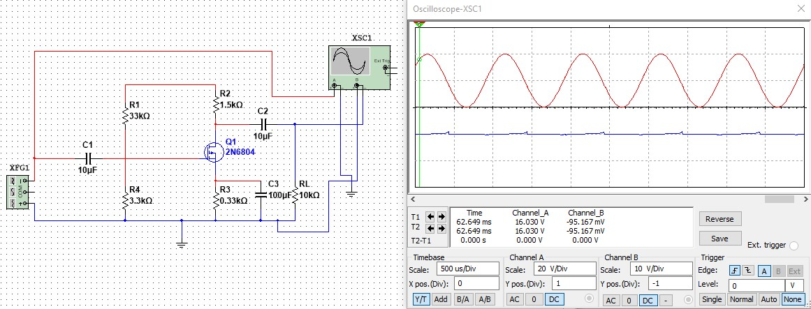 For load resistance 10 kilo ohm:

For load resistance 100 kilo ohm:

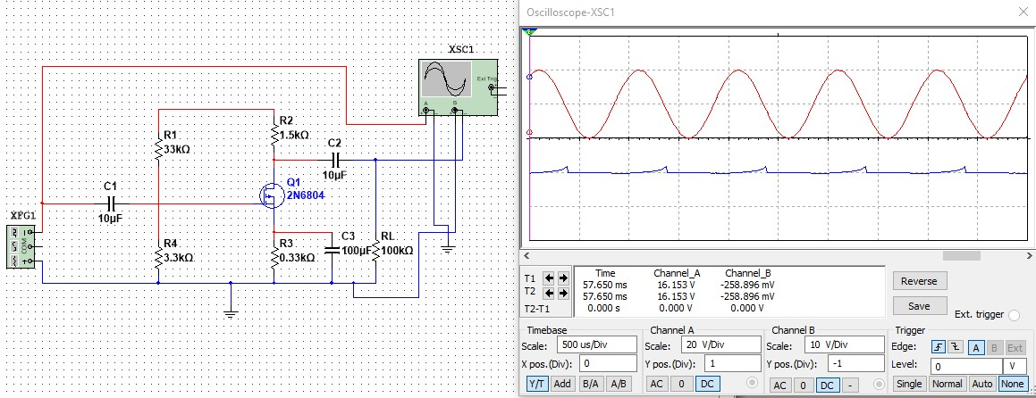

**Practical images:**

